Glossary  
Digital Marketing & E-commerce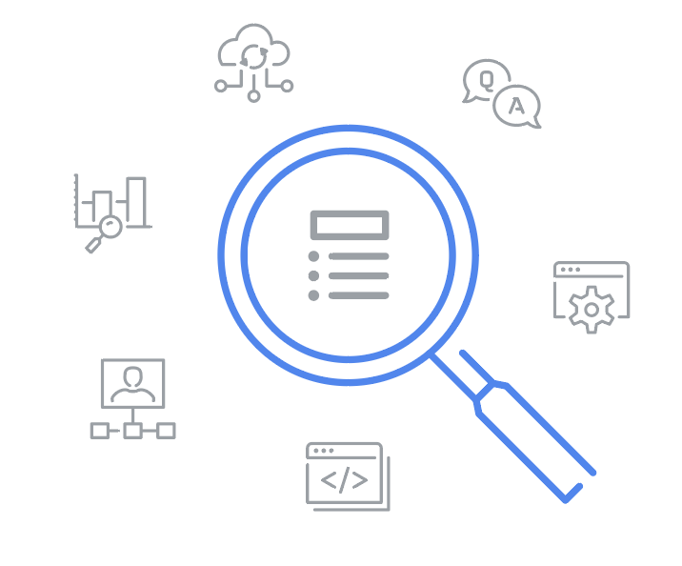

### **Terms and definitions from Course 1**

A

**Ad extension:** A Google Ads feature that shows additional information about the business

**Agency:** An outside partner that fulfills a company’s digital marketing and advertising needs

**Attribution:** Determining which content and channels are responsible for generating leads, conversions, or sign-ups

**Awareness stage:** The first stage of the marketing funnel, when a potential customer first becomes aware of the product or service

B

**Brand:** How a business or organization is perceived by the public

**Brand equity:** The value consumers attribute to one brand’s offerings when compared with similar products from another brand

**Brand safety:** Keeping a brand's reputation safe when they advertise online

**Business goal:** A desired aim, achievement, or outcome for a business

**Business-to-business (B2B):** Refers to when businesses sell products or services to other businesses (when businesses purchase from each other)

**Business-to-consumer (B2C):** Refers to when businesses sell products or services to consumers (when consumers purchase from businesses)

C

**Change management:** Methods, practices, approaches, and processes that organizations take to ensure changes are implemented smoothly

**Consideration stage:** The second stage of the marketing funnel, when a potential customer's interest builds for a product or service

**Consumer-to-business (C2B):** Refers to when individuals (consumers) sell products or services to businesses (when businesses purchase from consumers)

**Consumer-to-consumer (C2C):** Refers to when individuals (consumers) sell products or services to other consumers (when consumers purchase from each other)

**Content marketing:** A marketing technique that focuses on creating and distributing valuable content to a specific audience

**Conversion:** The completion of an activity that contributes to the success of a business

**Conversion rate:** The percentage of users or website visitors who completed a desired action, such as clicking on a link in an email or purchasing a product

**Conversion stage:** The third stage of the marketing funnel, when marketers capitalize on the interest people have already shown

**Cost per click (CPC):** The amount an advertiser pays when someone clicks on a PPC ad

**Customer journey:** The path customers take from learning about a product, to getting questions answered, to making a purchase

**Customer journey map:** A visualization of the touchpoints a typical customer encounters along their purchase journey

**Customer lifetime value (LTV or CLV):** The average revenue generated per customer over a certain period of time

**Customer persona:** Represents a group of similar people in a desirable audience

D

**Data:** A collection of facts or information

**Data analysis:** Examining data to draw conclusions, make predictions, and drive informed decision-making

**Data analytics:** Monitoring and evaluating data to gain actionable insights

**Data anonymization:** Techniques to mask or remove personal information from data to protect the identities of people

**Data bias:** Human error that skews data collection or interpretation of data in a certain direction

**Data-driven attribution:** Measures customer engagement with marketing content across channels to understand what is motivating them to take action

**Data ethics:** The study and evaluation of moral challenges related to data collection and analysis

**Data privacy:** Rights of individuals under the law to control how their personal information is collected, processed, shared, archived, and deleted

**Data pulling:** Collecting data from analytics tools and putting it in a spreadsheet or database

**Data reporting:** Organizing and summarizing data to track performance across marketing and sales efforts

**Data storytelling:** Conveying data insights to a specific audience using a clear and compelling narrative

**Data visualizations:** Graphical representations of data that convey information

**Digital channel:** Any communication method or platform a business can use to reach their target audience online

**Digital marketing:** The practice of reaching consumers online through digital channels with the aim of turning them into customers

**Display ad:** A visual ad format placed on websites or applications

### E

**Earned media:** Positive digital exposure generated through personal or public recommendations

**E-commerce:** The buying and selling of goods or services using the internet

**Email marketing:** Sending messages to a list of existing subscribers to share information, drive sales, or create community

**Engagement marketing:** (refer to **experiential marketing**)

**Experiential marketing:** The process of encouraging consumers to not only purchase a brand or product, but to experience it

### F

**First click attribution:** Assigns all the credit to the first touchpoint that eventually leads to a conversion

**Frequency:** How many times an individual encounters an ad

### I

**Impressions:** The total number of times an ad appears on people’s screens

**Inclusive marketing:** The practice of improving representation and belonging within the marketing and advertising materials that an organization creates

**Influencer marketing:** The process of enlisting influential people to endorse or mention a brand or product to their followers on social media

**In-house:** Within a single company

K

**Key performance indicator (KPI):** A measurement used to gauge how successful a business is in its effort to reach a business or marketing goal

**Keyword:** A search term people use to find information, products, and services online

L

**Last click attribution:** Assigns all the credit to the last known touchpoint before conversion

**Lead:** A potential customer who has interacted with a brand and shared personal information, like an email address

**Linear attribution:** Assigns equal credit to each touchpoint along the customer journey

**Local search:** A search query that generates local-based search results

**Local SEO:** Optimizing content so that it displays in Google's local search algorithms

**Loyalty stage:** The fourth stage of the marketing funnel, when customers become repeat customers and brand advocates

### M

**Marketing funnel:** A visual representation of the process through which people go from learning about a brand to becoming loyal customers

**Media mix:** A combination of digital channels marketers use to reach their goals and how they divide their budget among them

### O

**Omnichannel:** The integration or synchronization of content on multiple channels

**Owned media:** All the digital content a brand fully controls

### P

**Paid media:** Any form of digital promotion a brand pays to put online

**Pain points:** The problems customers want to solve

**Pay-per-click (PPC):** A type of advertising that allows the advertiser to pay only when someone clicks on an ad link

**Performance marketing:** The process of using concrete information about customer behaviors to plan and refine marketing and sales strategies

**Performance reporting:** (refer to **data reporting**)

**Personally identifiable information (PII):** Information that could be used to directly identify, contact, or locate an individual

### R

**Reach:** The total number of unique individuals who encounter an ad across their different

devices

**Return on ad spend (ROAS):** How much revenue is gained versus how much was spent

### S

**Search engine marketing (SEM):** Generating traffic to a website through paid ads that appear in search engine results

**Search engine optimization (SEO):** The process of increasing the visibility of website pages on search engines to attract more relevant traffic

**Search engine results pages (SERPs):**The pages of results a search engine produces when someone performs a search

**Segmentation:** Dividing an email subscriber list into smaller groups based on criteria like interests, location, or purchase history

**Social media marketing:** The process of creating content for different social media platforms to drive engagement and promote a business or product

### T

**Target audience:** The group of people most likely to purchase a company's products

**Touchpoint:** Any interaction a customer has with a brand during their purchase journey

**Transferable skills:** Skills from other areas that can help someone progress in a career in marketing